


W

At Eastgate Church, we LOVE KIDS. We have worship services just for kids on Sunday mornings at 10AM & 11:30AM and Wednesday nights during the school year. It is so much more than just babysitting- it’s an opportunity for kids to worship and connect with God at their level. We want to make the Bible come alive for kids; our goal is for kids to have a blast learning about God and growing in discipleship.

A high energy and kid-focused worship service every Sunday, with identical services at 10AM and 11:30AM.
Kids age 0-2 are in the nursery Main Building, room 106 Ages 3-4 (potty trained) are in the Preschool room (Main Building, room 103). K-5th grade meets in the Student Building in the Theater

On Wednesdays during the school year from 7-8PM, kids in K-5th are invited to a fun and exciting Bible-based program with skits, Bible stories, fun songs, games, and more! (Parents do not have to be on-site during Wednesday night services for kids; kids must be checked in).
Club 45; Preteen Ministry
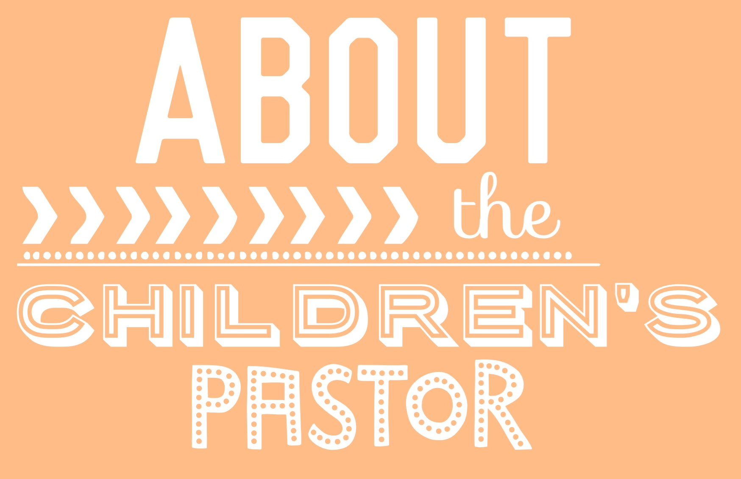
We have a special ministry JUST for 4th/5th graders. This ministry meets on Sunday mornings periodically, and Wednesday nights during the school year, and has monthly special events. Club 45 aims to reach preteens with lessons, games, and activities to help them grow in their faith.

Lynne Howard has a degree in Children’s Ministry from Indiana Wesleyan University, and is passionate about serving God and helping kids connect with Him. She and her husband moved here from Tuscaloosa, AL. She loves helping kids know and experience Jesus, and would love to get the opportunity to connect with you or answer any questions. Email: lynne@myeastgate.org
Eastgate Church
www.eastgatechurch.org


We are here to partner with parents, and look forward to serving you through our Nursery Ministry. Our nursery welcomes babies age 6 weeks – 3 years.
Our nurseries are staffed with trained, caring workers. We understand the importance of helping little ones feel comfortable, so we have consistent nursery leaders who will care for your baby regularly. Our nursery leaders are CPR certified, and have undergone training and background checks. We teach babies age appropriate, fun Bible lessons.

For parents who wish to keep their children with them, we have a Nursing Room near the sanctuary where parents can sit with their children and still see and hear the service.
We take your children’s safety seriously, and we have safety policies in place to help protect the children in our children’s ministry.
Check-in Procedures
- All children 5th grade and under must be checked in by a parent or designated adult for all ministry functions.
- Upon check-in, a claim card (a sticker with your child’s name on it) will be given to the adult. This claim card must be presented to the leader or security leader in order pick up children after the service
- Children are in the care and supervision of their parents at all times when they are not checked-in, before or after services.
- Check-in opens 15 minutes before a service starts and the check-in desk closes 15 minutes after the service has started.
FREQUENTLY ASKED QUESTIONS about Safety Policies
Why do I need a Claim Card? Each parent/guardian is given a sticker that matches their child’s, which the parent will turn in (to the security person) in order to pick up the child after the service, to ensure that all the children leave with the correct guardian.
What if we arrive late? If you arrive late, check your kids in using the iPad Self Check-in Station or alert a children’s ministry leader to check in your child, and let the child’s teachers know you have arrived.
What if I drop my kids off, but another adult needs to pick them up? You should give the other adult the claim card, and let the security guard or group leader know ahead of time that someone else will be picking up your children. (Siblings cannot pick up kids unless approved, or considered the child’s guardian during that time, and have the parents’ permission and the claim card).
What if I forget/lose my claim card? You must see the Children’s Pastor and present ID.
How will you contact parents if there is an emergency? When you fill out a Registration Form, we will enter your information into our secure computer check-in system. If there is an emergency, or we need to get ahold of a parent for any reason, you will receive an SMS text message on your cell phone (please leave it on vibrate, so it doesn’t disrupt the service), which will alert you, asking you to report to your child’s classroom.
What else does the church do to help protect my children? Our church takes your children’s safety very seriously. To help protect children, we have trained security guards present, and all volunteers are screened and background checked.
For more information about any of the above programs or our children’s ministry, or to talk with the children’s pastor, contact Lynne Howard at 770-888-8852 or email lynne@myeastgate.org

